**Data Analytics at Acme TelCo.**

**Description of the DataSet:**

Acme Telco is a small telcom company that develops Sells and installs telecommunication devices such as network routers, conference call hardware etc. for business needs. Acme has been operating for over a decade with a modest current headcount of close to 200 people and it is organized itself around the following 5 departments: Operations, IT Sales, Software engineering and Admin.

We have been given a dataset with three different data sets containing:

1. Basic Employee Data, (HRIS-1)
2. Employee performance and attendance data (HRIS-2)
3. Employee salary data (FIS)

**Establishing the connection between the tables:**

Connect the dataset to the tableau desktop through Microsoft excel. Now we can see that the dataset is connected. Then drag the HRIS-1, HRIS-2 & FIS to the data source.

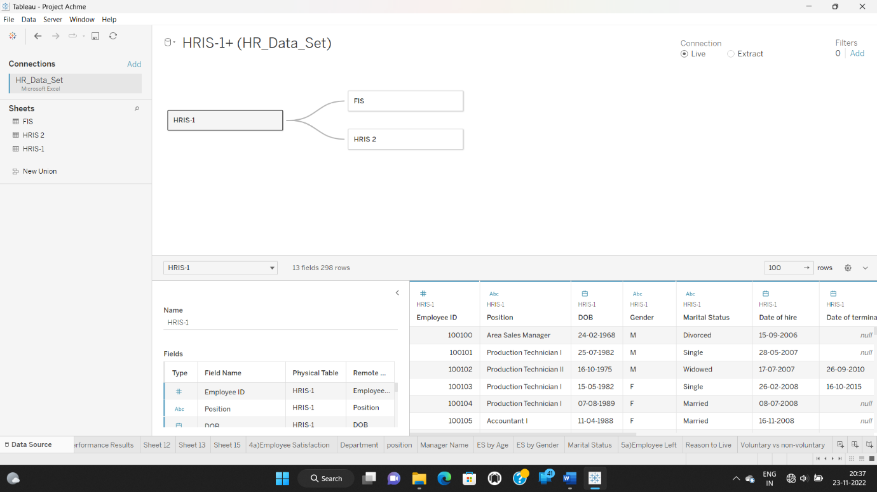

After establishing a successful connection between the tables, we have to move forward and open sheet-1 to see the Data Visualization graphs for the expectations of the company.

1. **Group size and demographics**
2. How many employees are currently employed by each department?

* To get how many employees are currently active drag HRIS-1(Count) to columns and department to rows and then drag employment status to filter and keep active. Drag department to colors to get different colors department wise

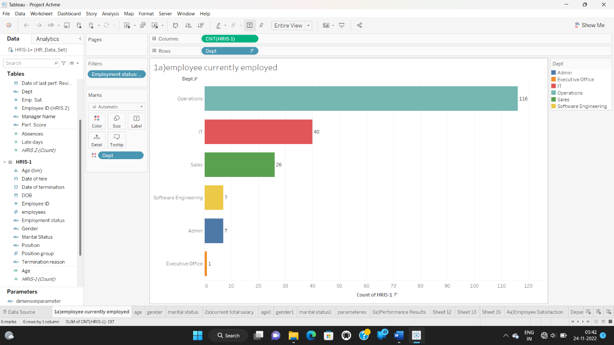

**Insight:** The largest department is Operations with 116 employees, followed by IT, Sales, Admin, Software engineering and Executive office with 40, 26, 7, 7, and 1 employee respectively.

b. What are the demographics of our current employees?

1. Age:

● Create a calculated field called ‘Review Date’ with text ’31-Dec-2020’

● Create a calculated field to compute age (‘Age’) with the following calculation. **ROUND(([Review date]-[DOB])/365,0)**

To get age we need to create age bins and then drag age(bin) to columns and HRIS-1(Count) to rows and keep employment status active in filters and drag age(bin) to colors.

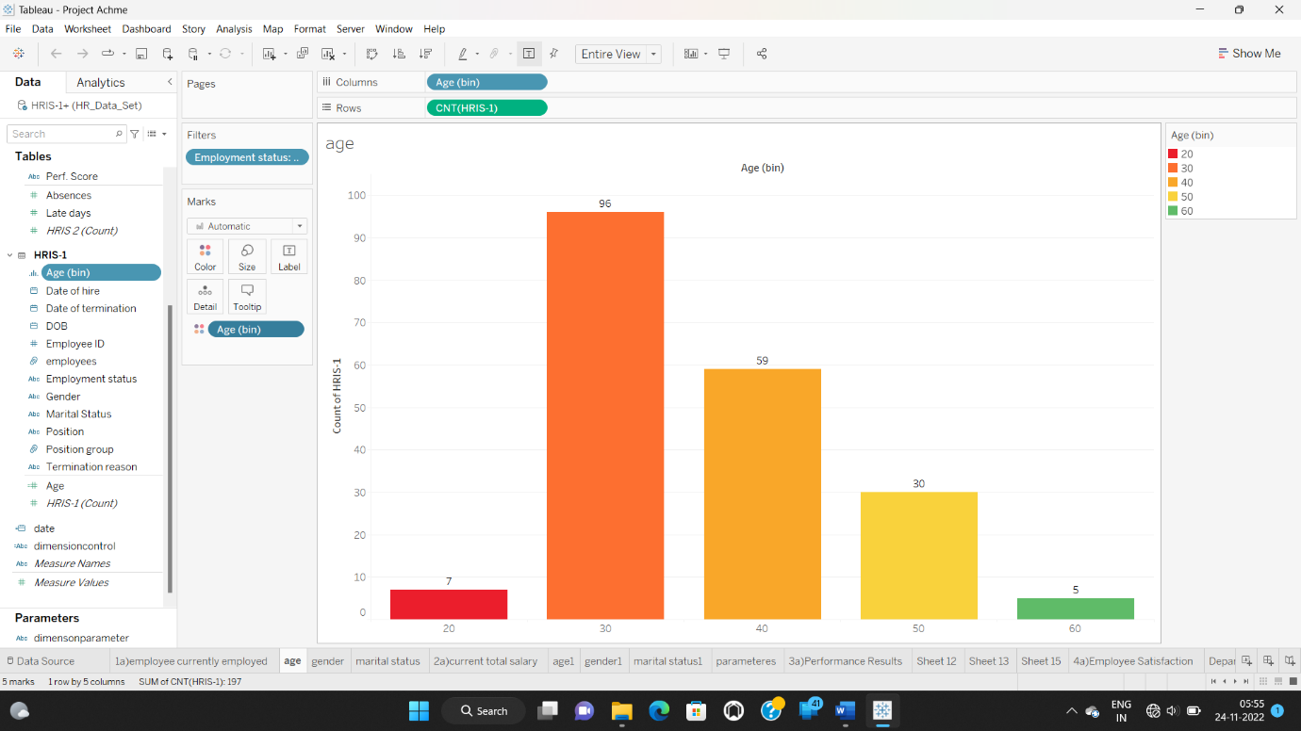

**Insight:** The age group with more number of employees is 30-40 containing 96 as compared to 20-30, 40-50, 50-60 & 60-70 having 7, 59, 30& 5 employees respectively.

2. Gender:

● Bring Gender to rows and HRIS(Count) to columns

● Filter for active employees

● Enable text labels

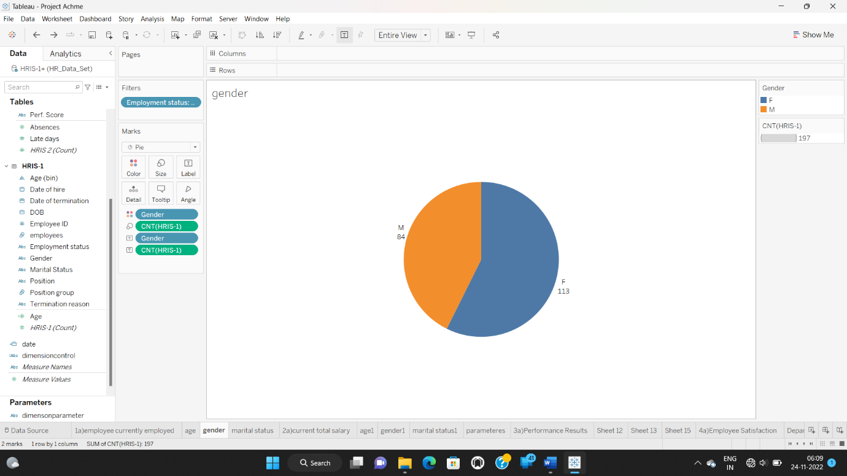

**Insight:** The company has more females than male employees – 113 and 84 respectively.

3. Marital Status:

● Bring Marital status to rows and HRIS(Count) to columns

● Filter for active employees

● Enable text labels

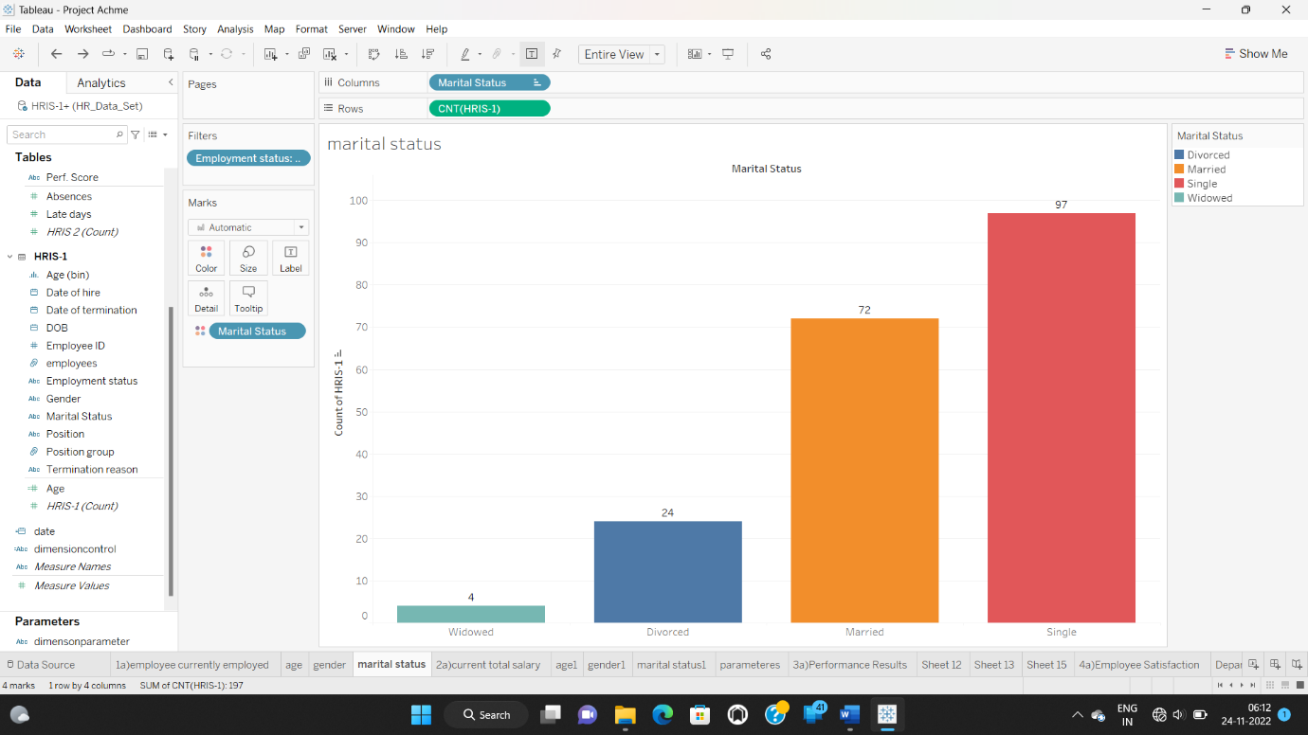

**Insight:** Most of the employees are single – 97, followed by married, divorced, and widowed – 72, 24, and 4 respectively.

1. **Salary structure?**

a.) What was the current total salary expense for each department?

● Bring Dept to rows and Salary to columns

● Duplicate the Salary field in the columns and convert the aggregation to ‘Avg’

● Filter for active employees and enable text labels

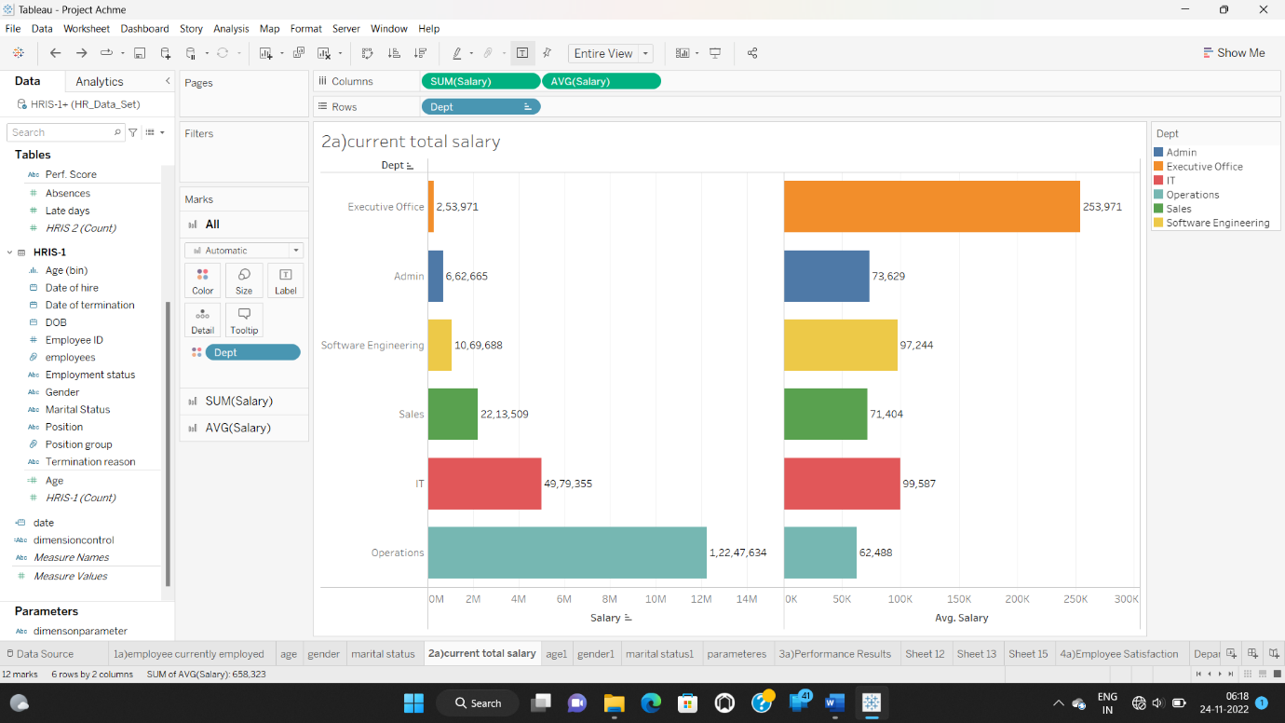

**Insight:** Among all the departments Executive office is high as compared to all other departments.

b.) What is the salary structure for each demography of our current employees?

1. Age:

● Bring the Age (bin) to the columns and salary to the rows

● Duplicate salary in the rows and convert aggregation to Avg

● Filter for active employees and enable text labels

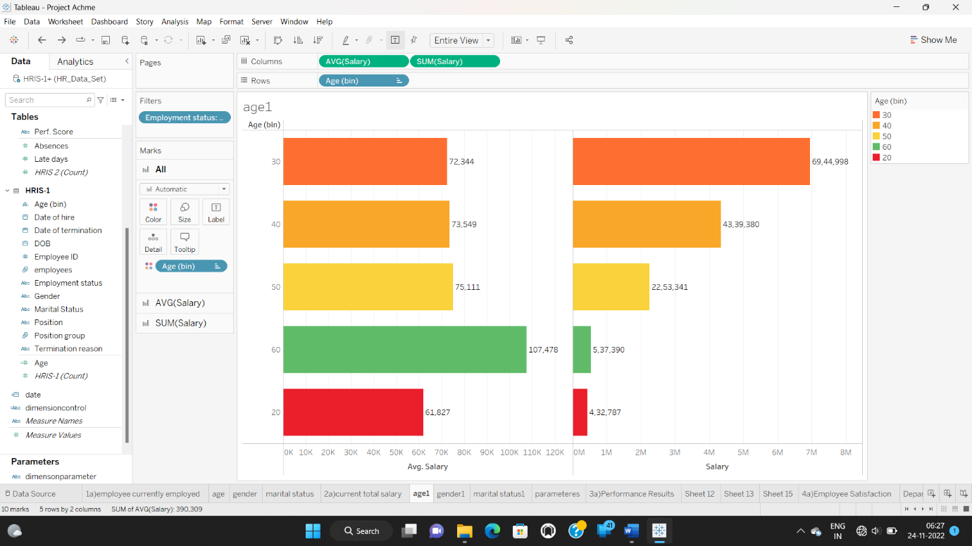

**Insight:** In terms of Avg salary 60+ age group people have more salary as compared to other age group people. In terms of salary 30-40 age group people have more salary as compared to other age people.

2. Gender:

● Bring Gender to the rows and Salary to the columns

● Duplicate Salary in the columns and convert the aggregation to show Avg

● Filter for active employees and show the text labels

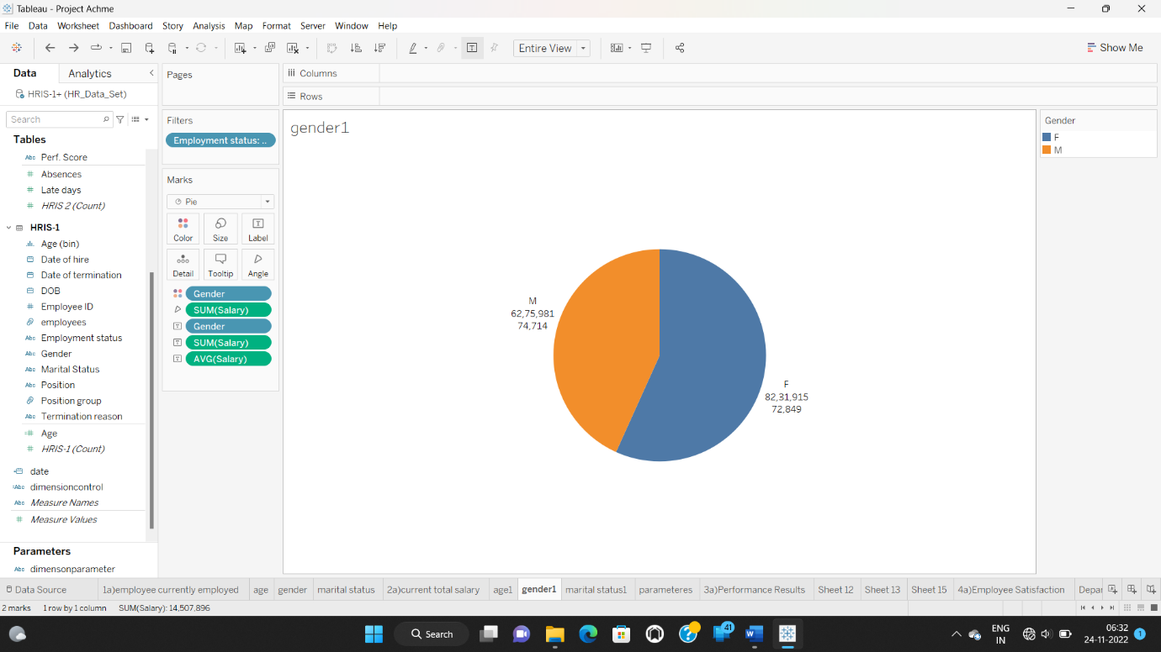

**Insight:** More salary expenses is going to females as compared to males, but avg salary is more for males as compared to females.

3. Marital Status:

● Bring Marital Status to the rows and Salary to the columns

● Duplicate Salary in the rows and convert the aggregation to show Avg

● Filter for active employees and show the text labels

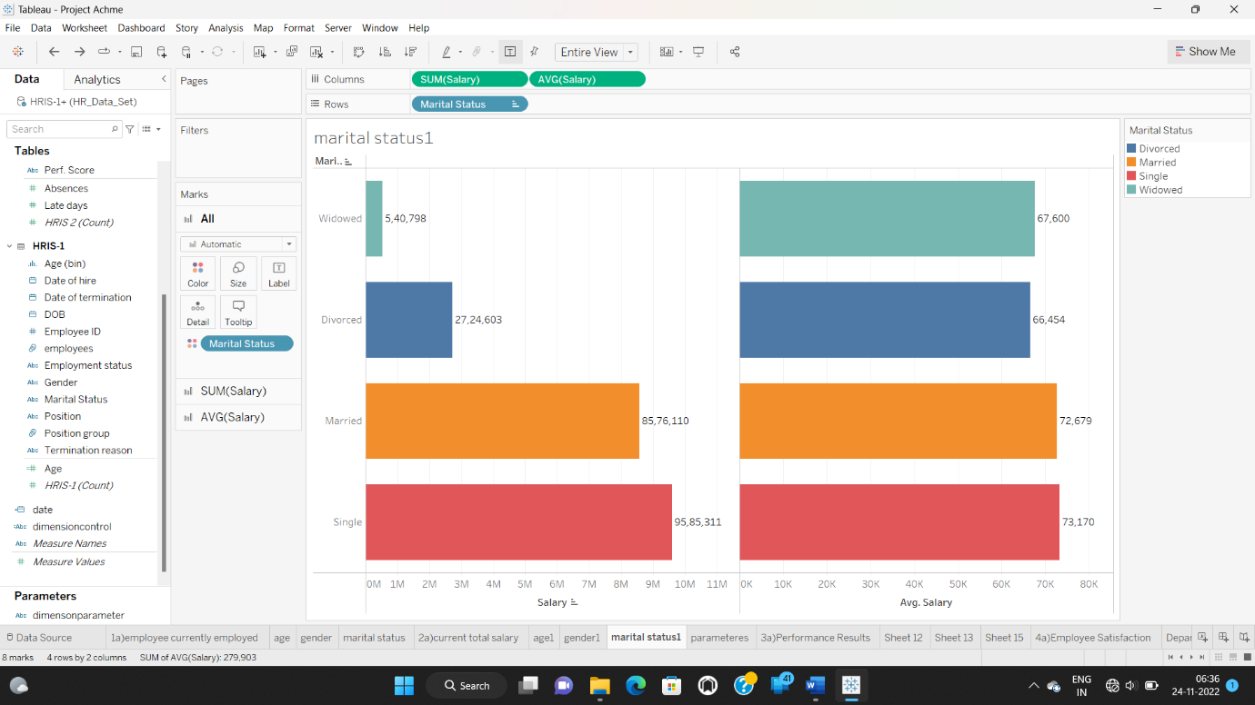

**Insight:** In terms of salary and avg salary Singles are more as compared to Widowed, Divorced & Married.

1. **Performance results**

a.) What was the distribution of employees in terms of their performance?

● In order to create a distribution of employees by performance, bring ‘Perf. Scores’ to columns and HRIS (Count) to the rows

● Filter for active employees and show the text labels

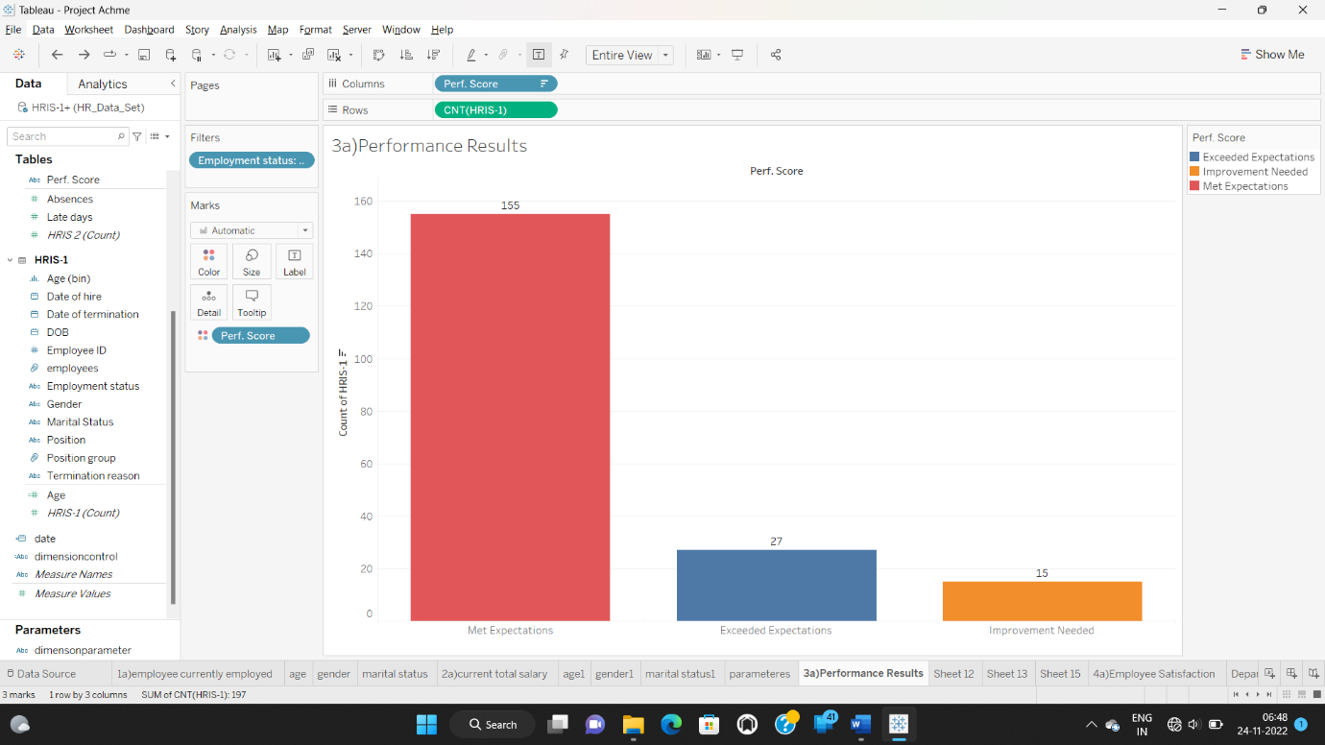

**Insight:** We can see that 155 employees Met Expectations, 27 employees Exceeded Expectations & 15 employees need improvement in the performance.

* Click on the sheet and add new worksheet and drag perf.score to columns and HRIS-1(count) to rows. Right click on HRIS-1(count), Open table calculation and select percent of total in calculation type.

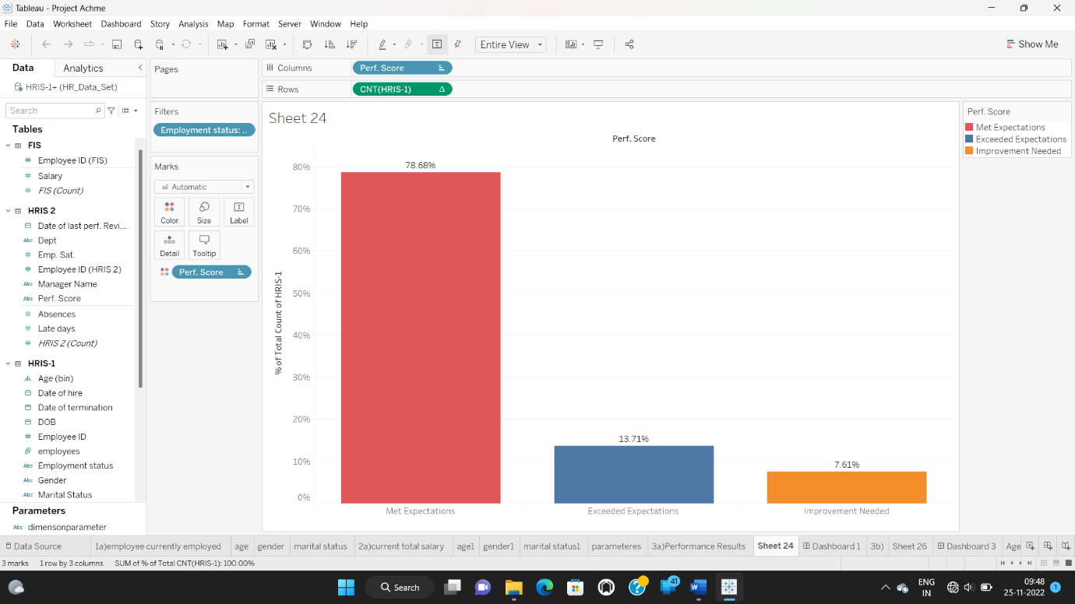

* Then click on the sheet and select new dashboard and drag the two sheets in to the dashboard. Now you can see the comparison of two graphs.

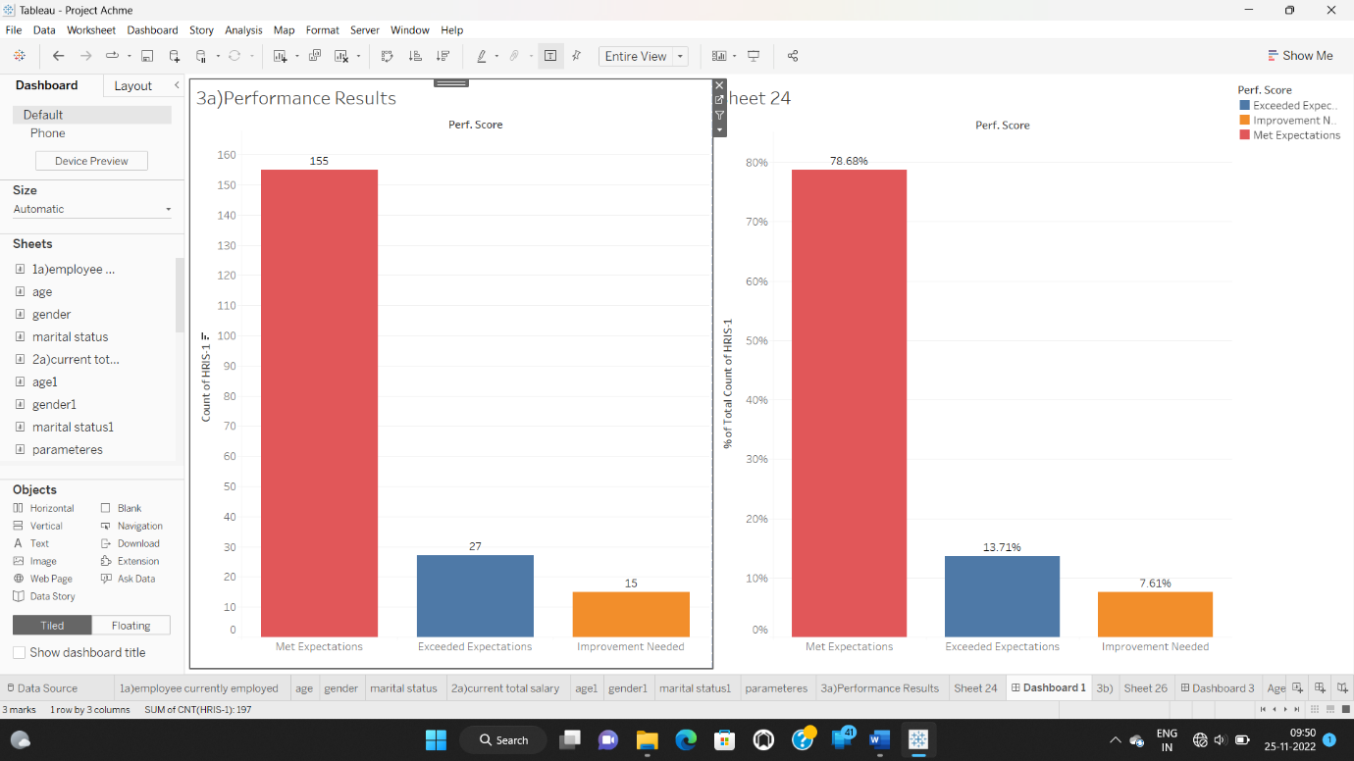

**Insight:** from that graphs we can compare two graphs containing score and total of percent at the same time.

b.) Could we do a deep dive per group?

1. Department:

● Bring ‘Perf Score’ to the columns and DimensionControl to rows

● Include the HRIS(count) in the text

● Select Dept from the parameter control

● Filter for active employees

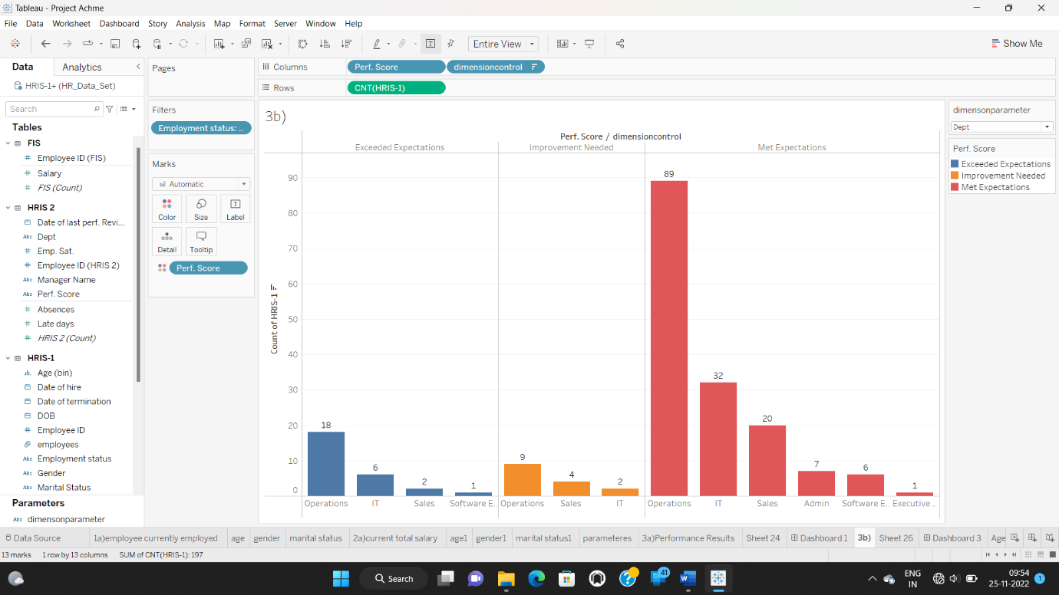

**Insight:** Among all departments Operation department have high score regarding to expectations wise.

* Duplicate this and include table calculation in the text to show the % total across rows.
* Bring these two charts to a new dashboard to analyse together.

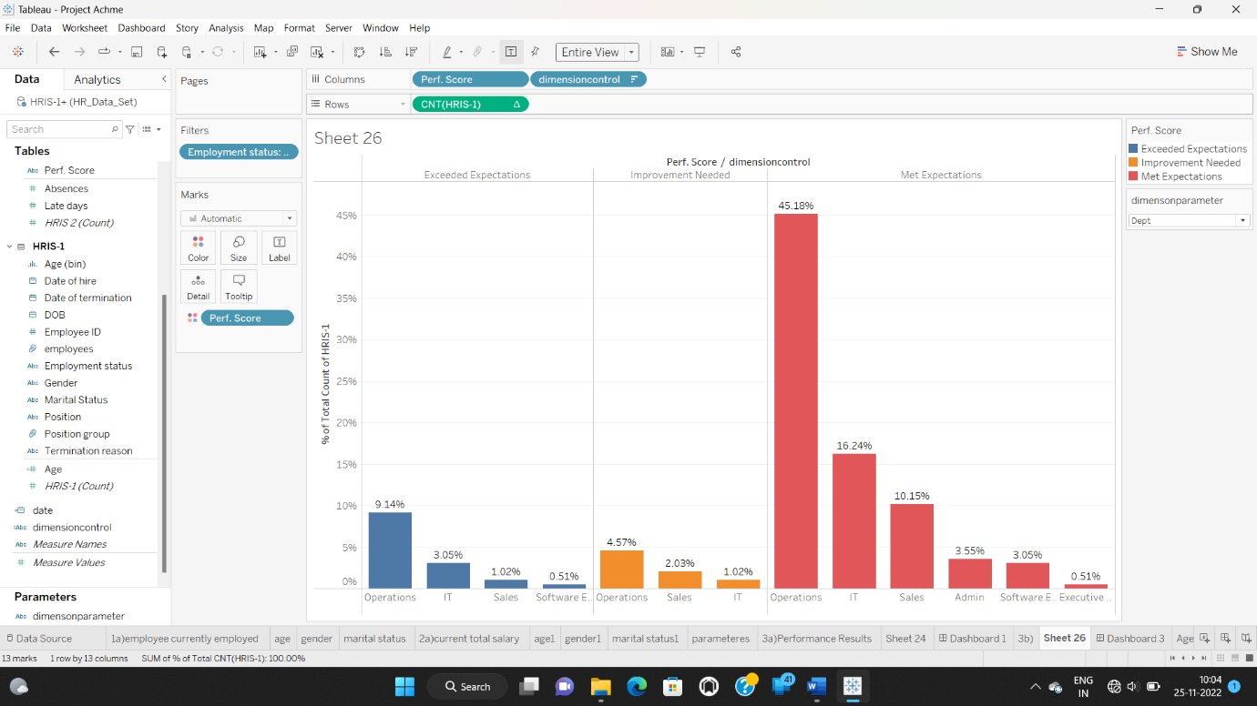

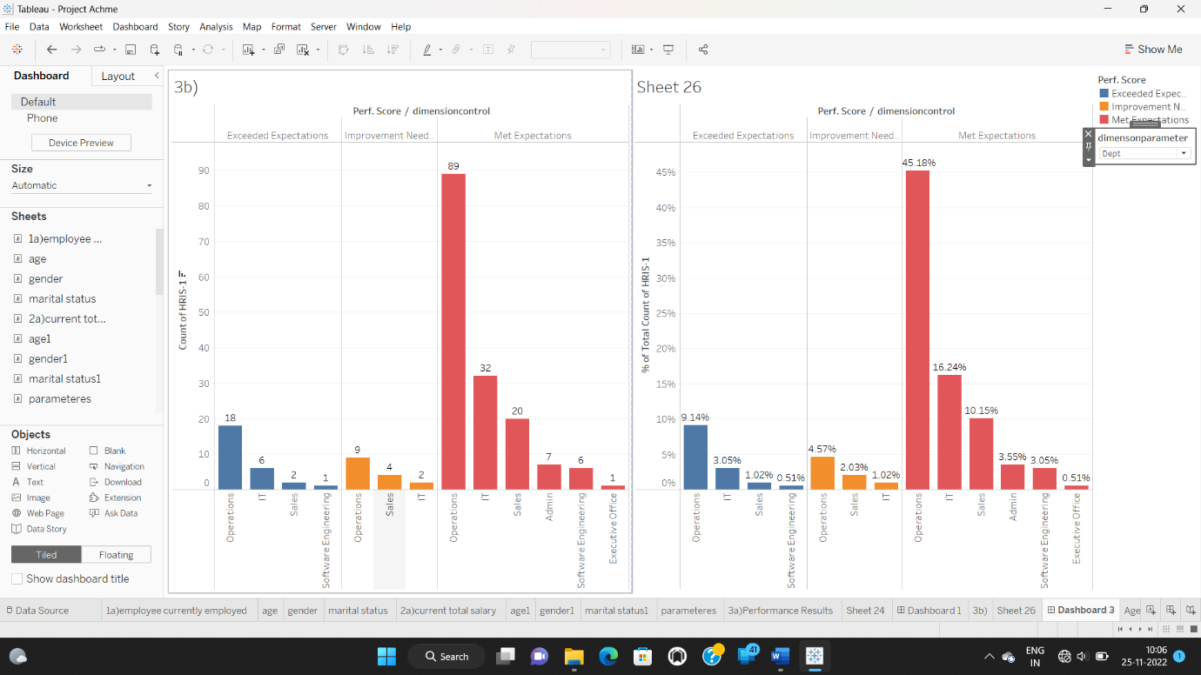

**Insight:** from that graphs we can compare two graphs containing score and total of percent at the same time for different departments.

2. Performance by Manager Name:

● Update the parameter and calculated field for parameter control to include the ‘Manager name’

● From the parameter control, select ‘Manager Name’ .

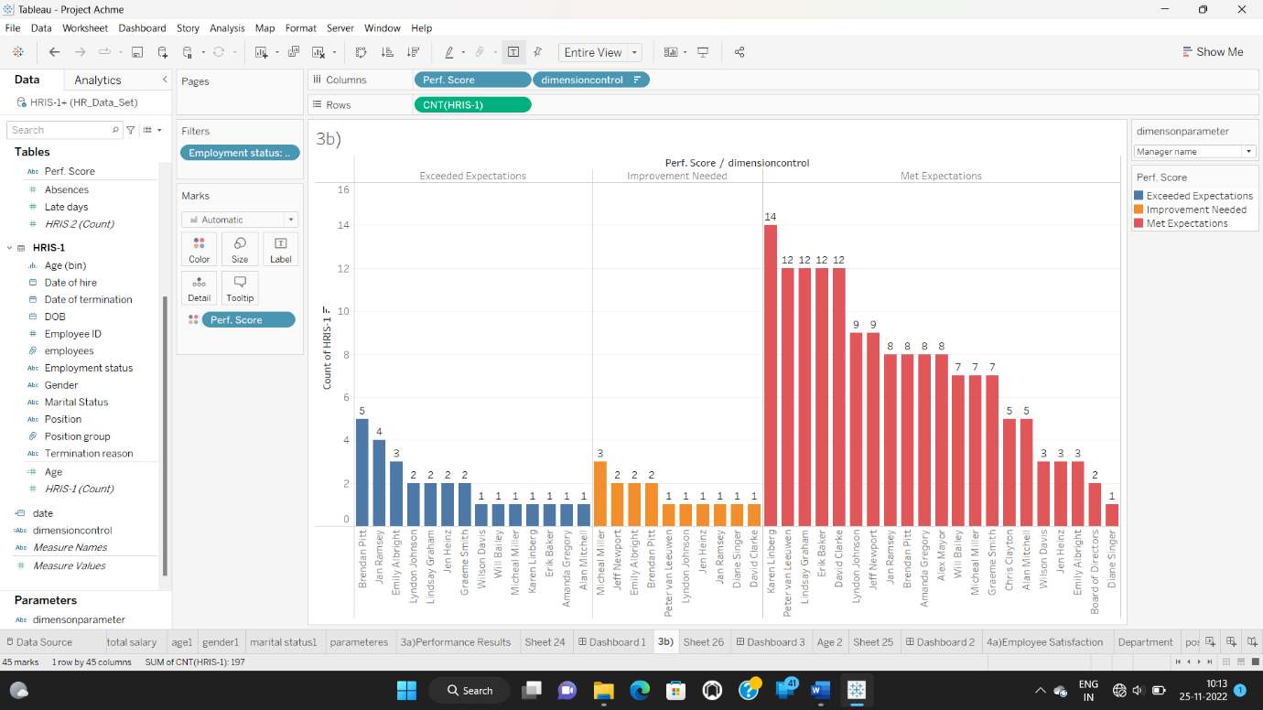

**Insight:** Now we can see the manager names by perf.score wise.

* Duplicate this and include table calculation in the text to show the % total across rows.
* Bring these two charts to a new dashboard to analyse together.

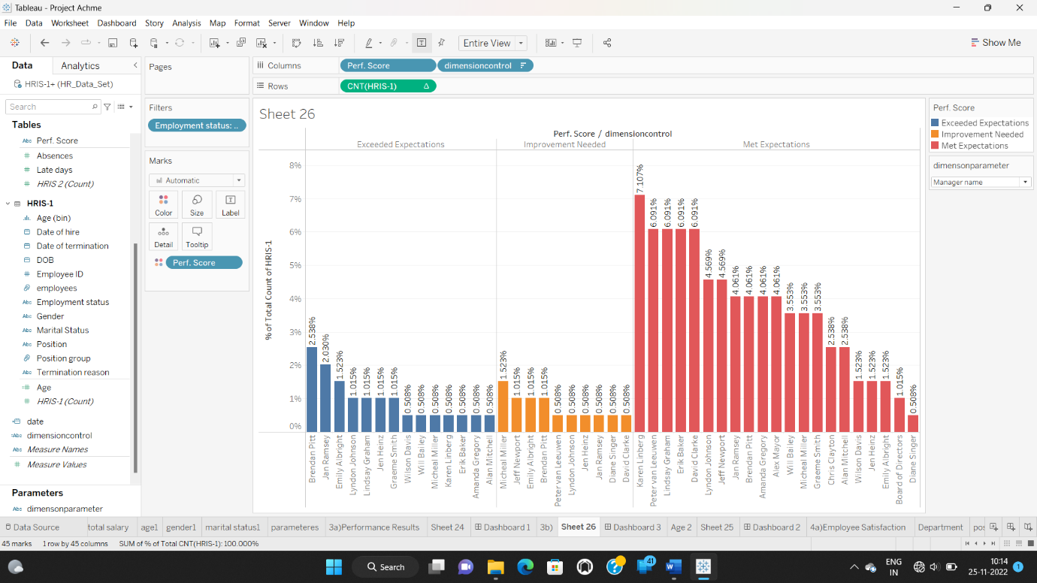

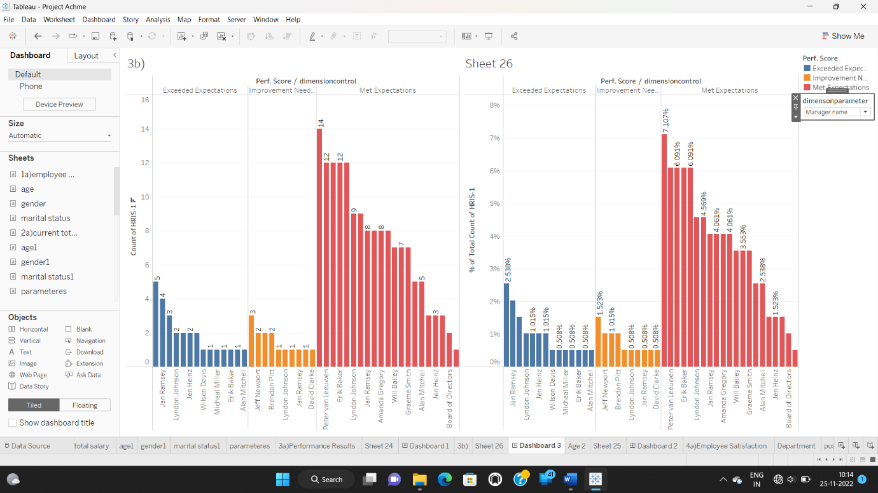

**Insight:** Now we can compare the manager names by perf.score and total of percent wise in the form of exceptions wise.

3. Performance by Age :

● In order to create a distribution of employees by performance and age, bring ‘Age (bins) to columns and HRIS (Count) to the rows, bring ‘Perf Scores’ to the colors. We could also use the cross table created earlier.

● Include table calculation Change the HRIS (count) to show % total

● Filter for active employees and show the text labels

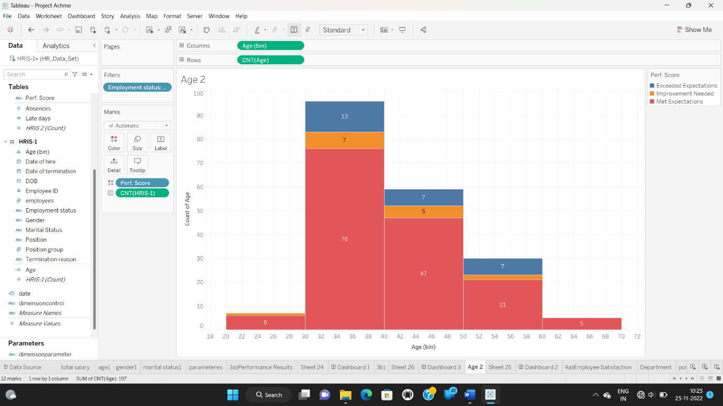

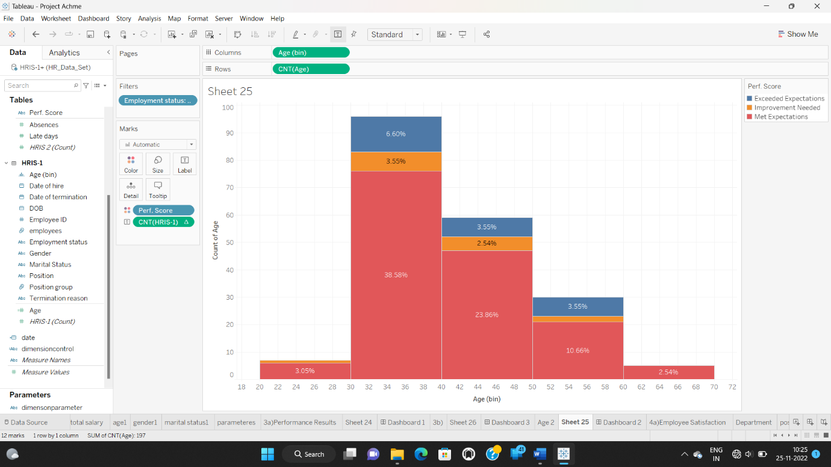

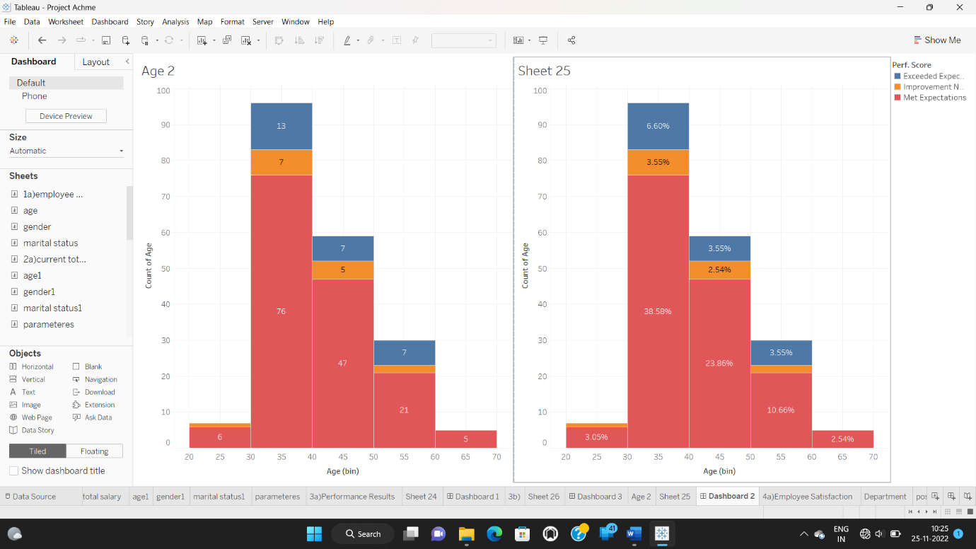

**Insight:** Now we can compare the age in percent wise and number wise. 30-40 age people have more compared to other age group.

4. Performance by Gender:

● From the dashboard created earlier, select ‘Gender’ from the dimparameter control.

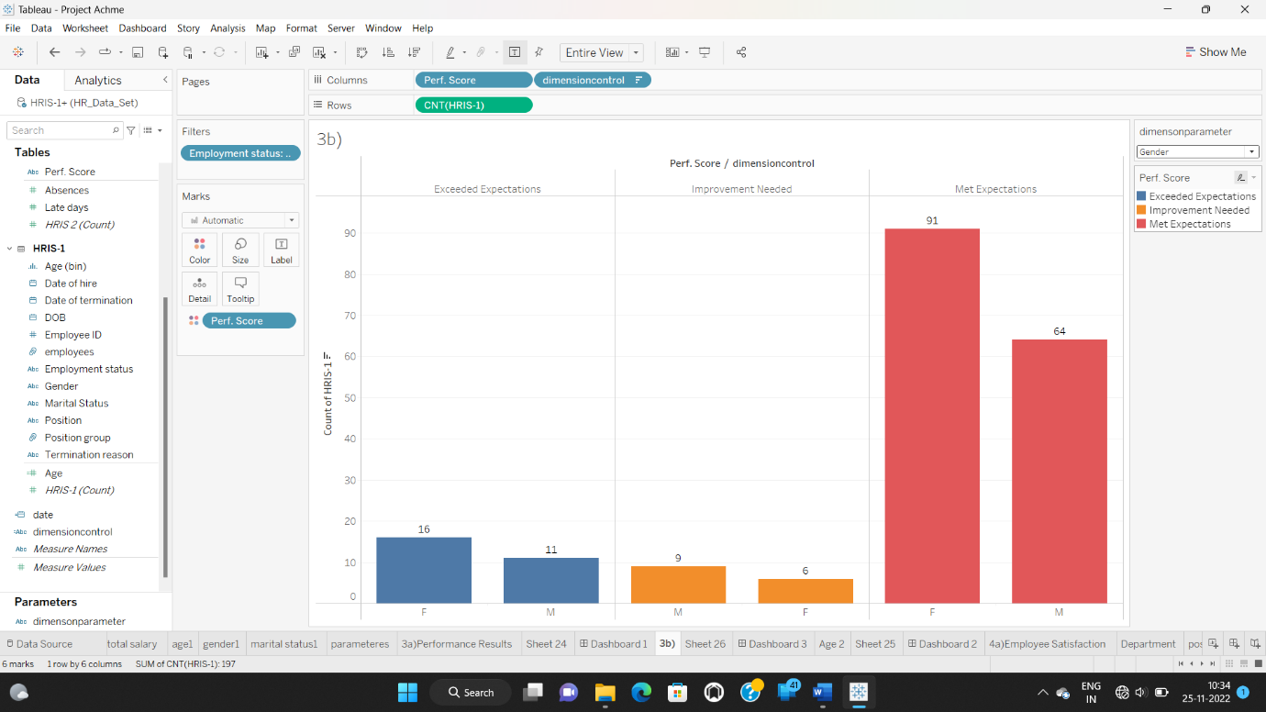

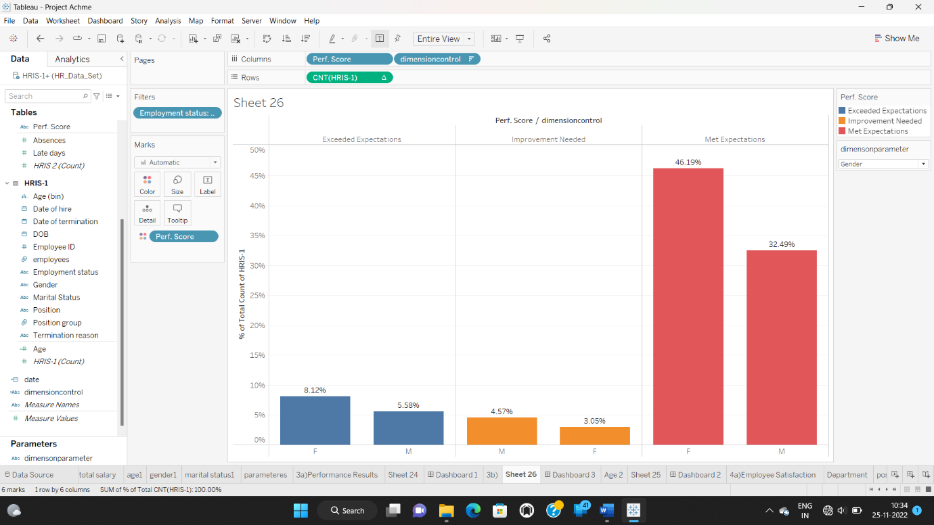

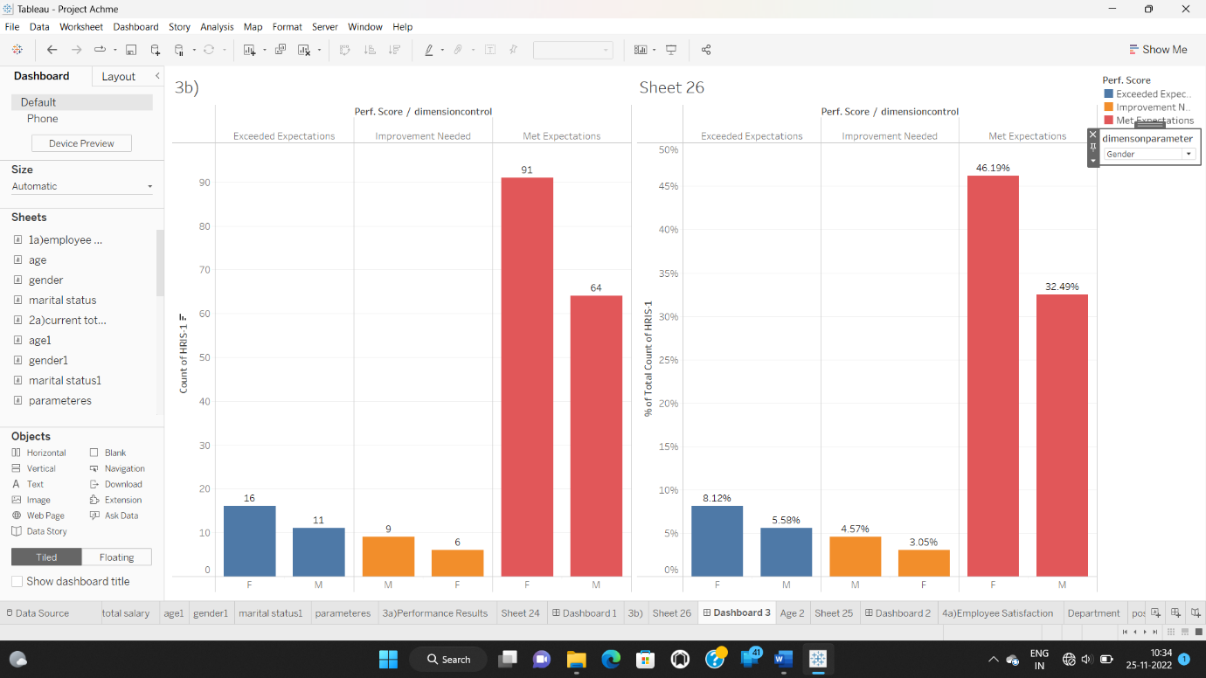

**Insight:** we can see females are more in number as compared to males in exceed and met exceptions compared to improvement exceptions.

5. Performance by Marital Status :

● From the dashboard created earlier, select ‘Marital Status from the dimparameter control.

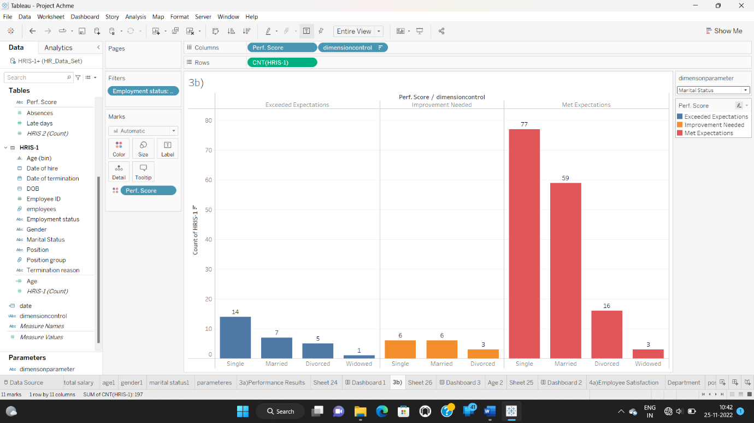

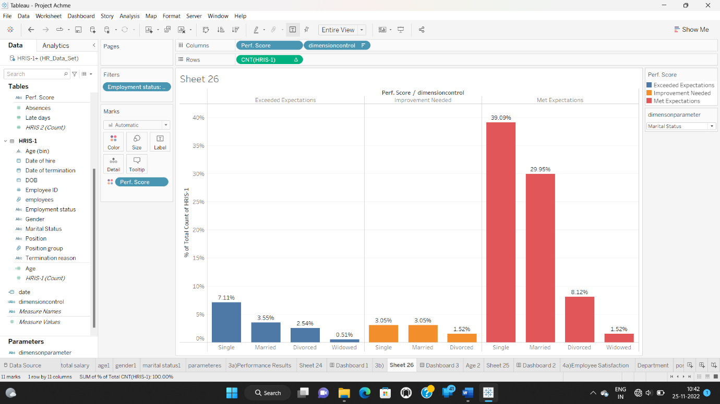

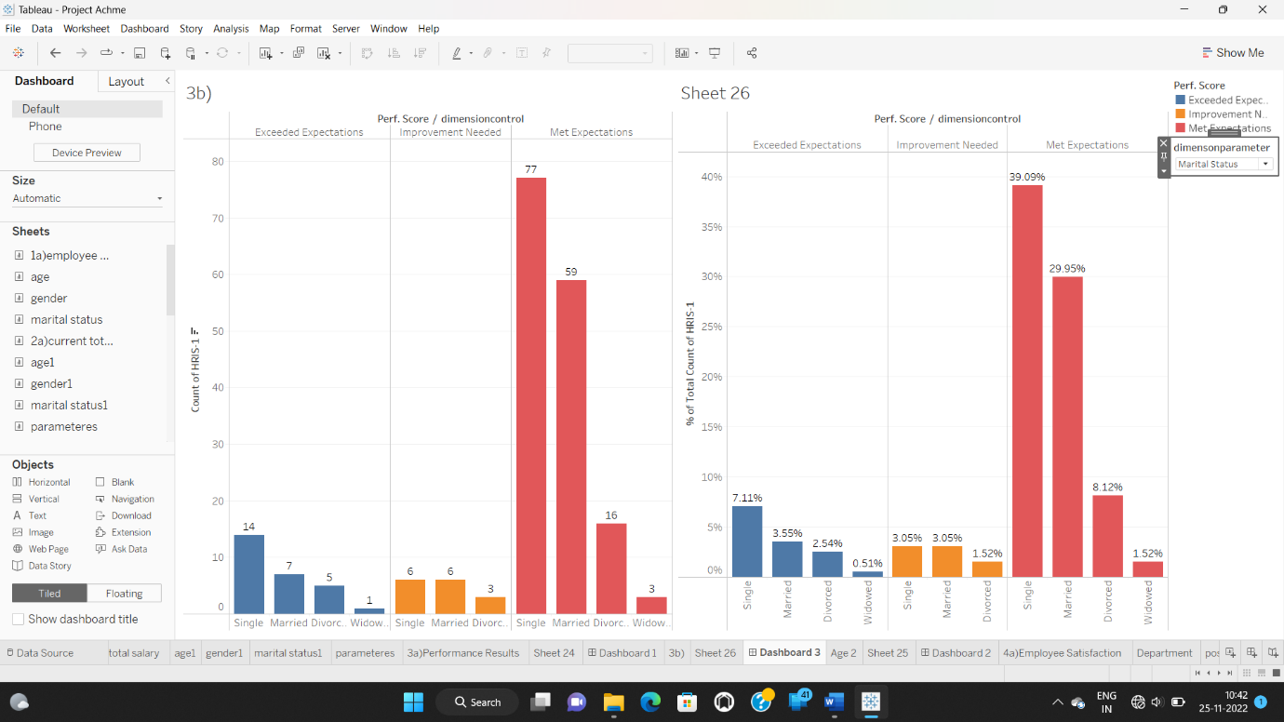

**Insight:** From the above graph we can see that Singles are more in number and total of percent as compared to the Married, Single & Widow.

5. Performance by Position:

● From the dashboard created earlier, select ‘Position’ from the parameter control.

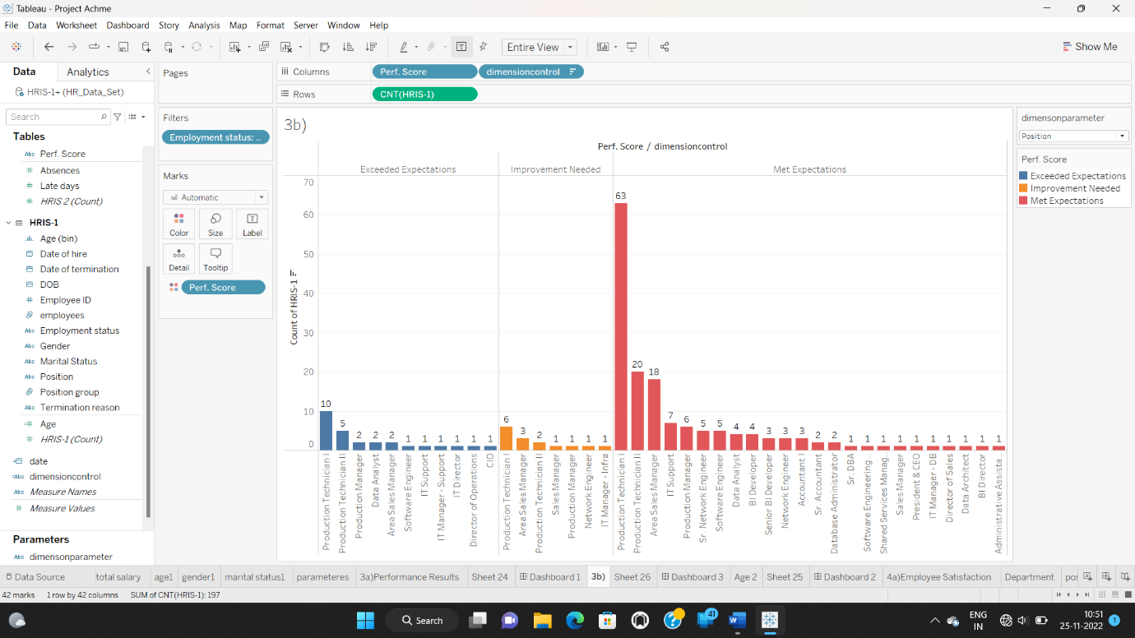

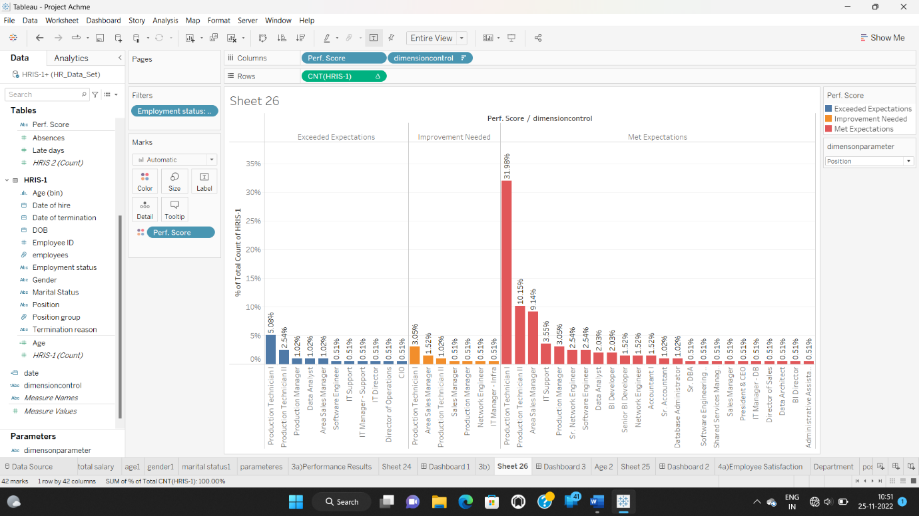

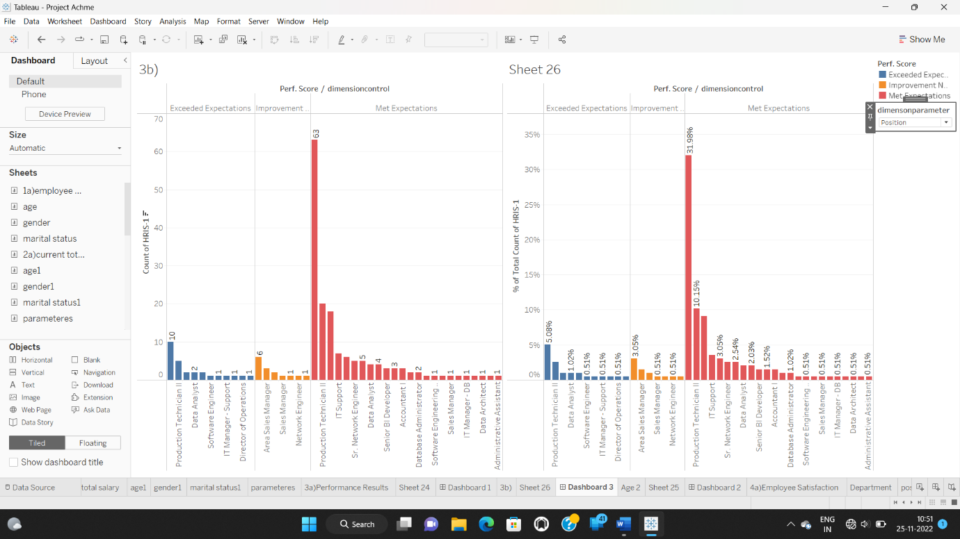

**Insight:** Production technician II has more perf.score as compared to other position groups.

1. **Satisfaction scores:**

a.) How satisfied our employees are?

● Create a chart similar to the ones earlier to show ‘Emp sat dim’ vs count of rows. Note that we convert the emp. Sat into dimension and used in this chart

● Filter for active employees and show text labels

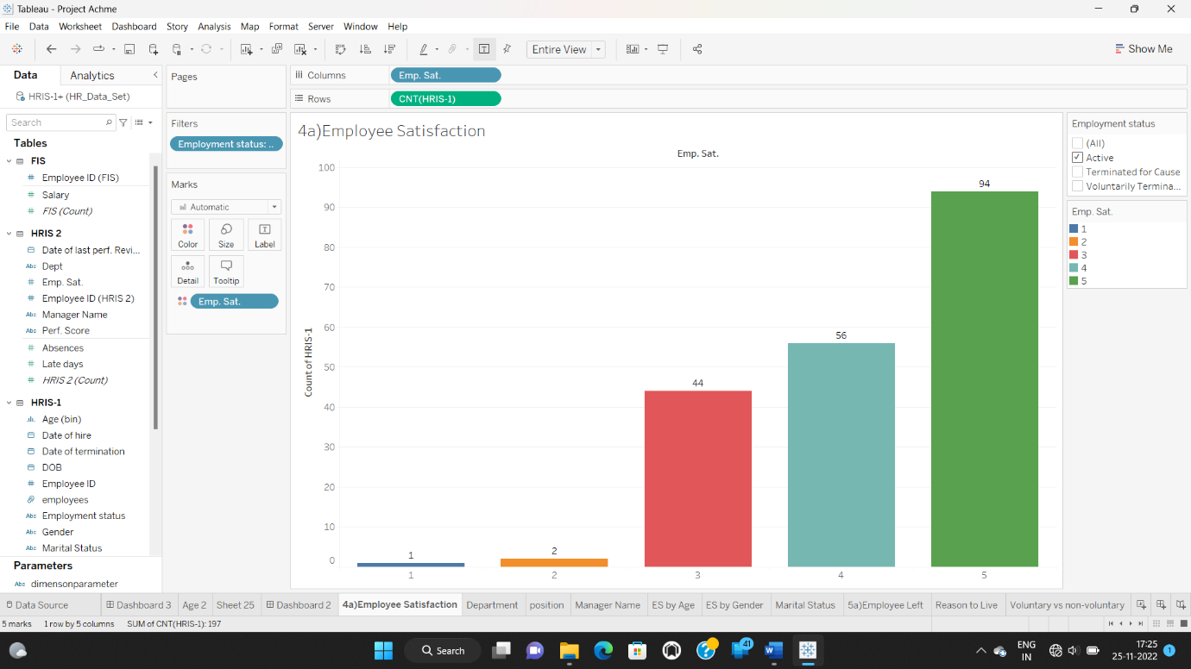

**Insight:** Emp.sat is a discrete dimension contains 5 fields. Field 5 has more in number 94 as compared to remaining 4 fields 4,3,2,1 containing values 56,44,2,1.

b.) Could we do a deep dive per group?

1. Department:

● Similar to the previous chart, we create a chart showing average employee satisfaction Vs parameter control

● Select ‘Dept’ from the parameter drop down

● Filter for active employees and show text labels

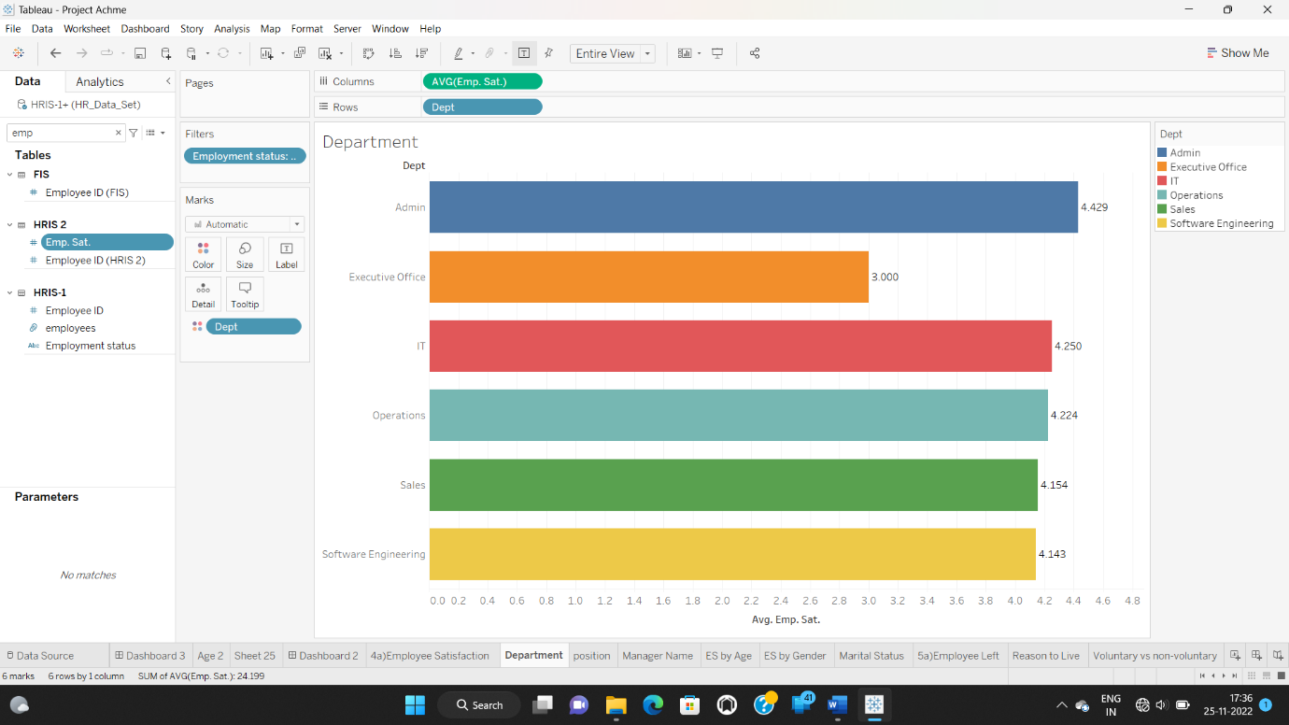

**Insight:** Admin department have high Emp.Sat. as compared to remaining departments.

2. Manager Name:

● Select ‘Manager name’ from the parameter drop down

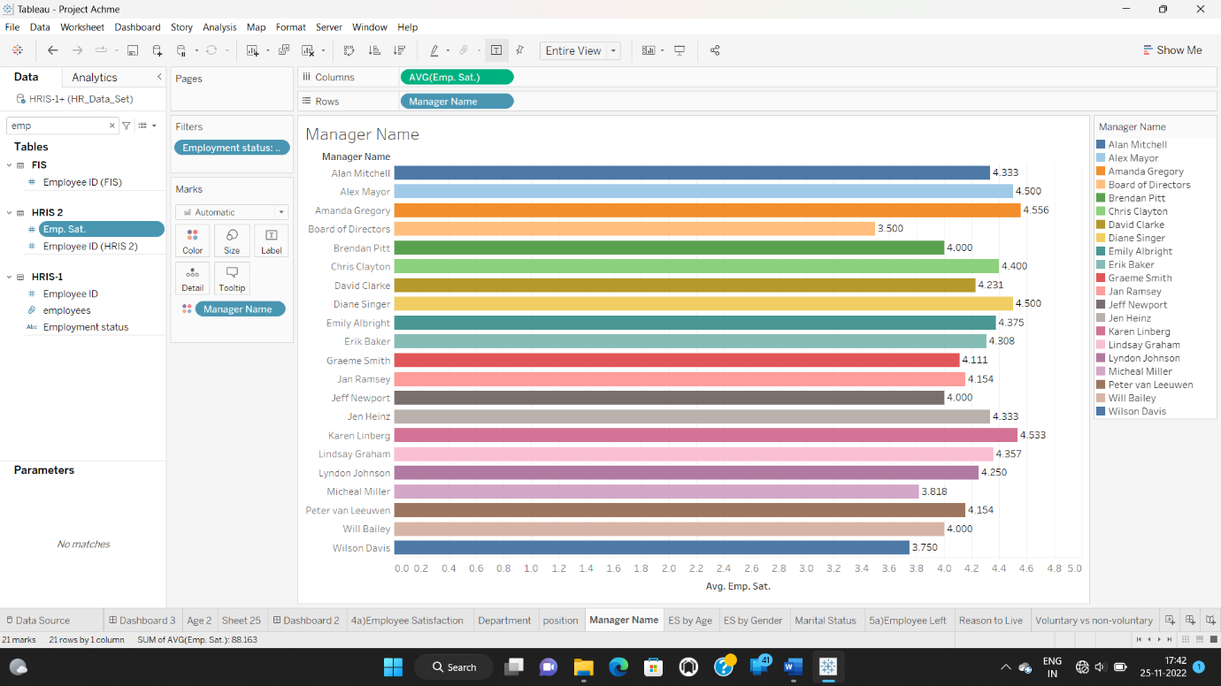

**Insight:** Manager Amanda Gregory has high avg Emp.sat. as compared to remaining managers.

3. Position:

* Drag dimensioncontrol to columns
* Drag emp.sat to rows
* Put employment status active and keep dimensioncontrol in color.

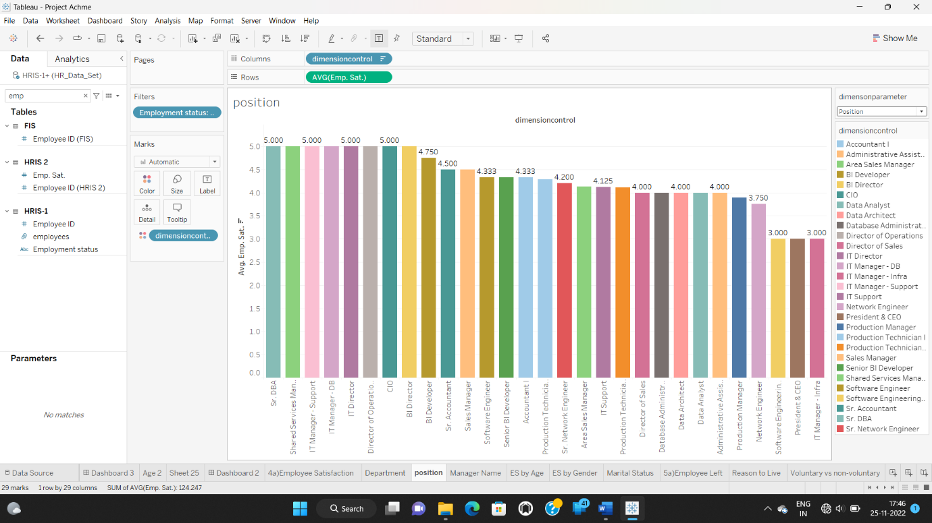

**Insight:**

4. Age:

● Construct Age (bin) Vs average employee satisfaction

● Filter for active employees and show labels

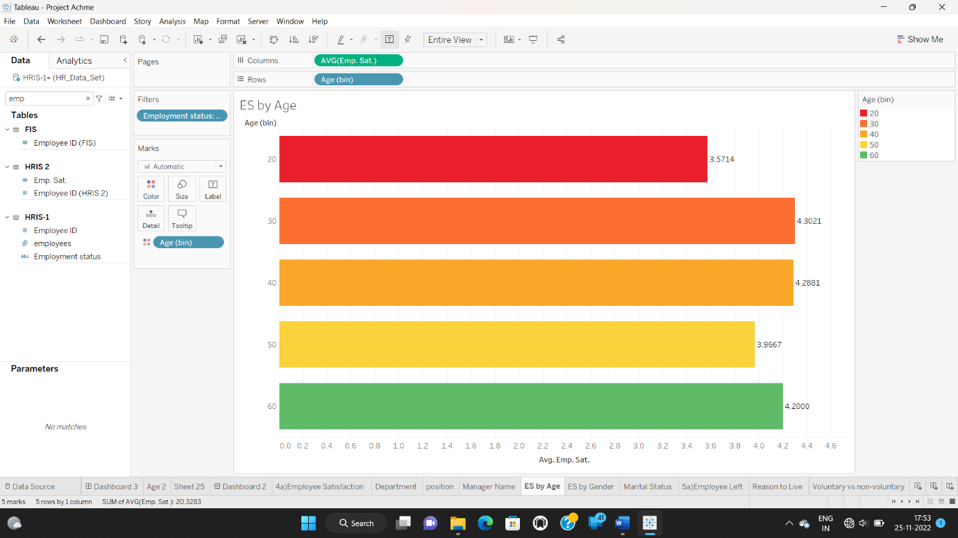

**Insight:** 30-40 age group people has high avg emp.sat. as compared to remaining age group people.

5. Gender:

* Drag emp.sat to columns
* Drag gender to rows
* Put employment status active and keep gender in color.

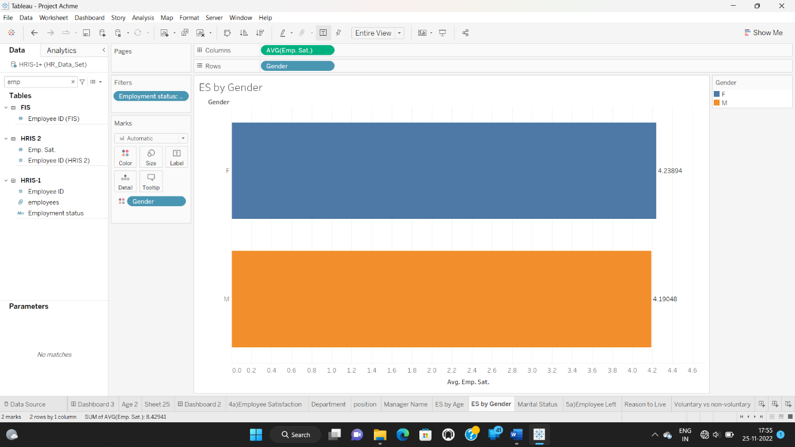

**Insight:** males are more in number as compared to females.

6. Marital Status:

* Drag emp.sat to columns
* Drag Marital Status to rows
* Put employment status active and keep Marital Status in color.

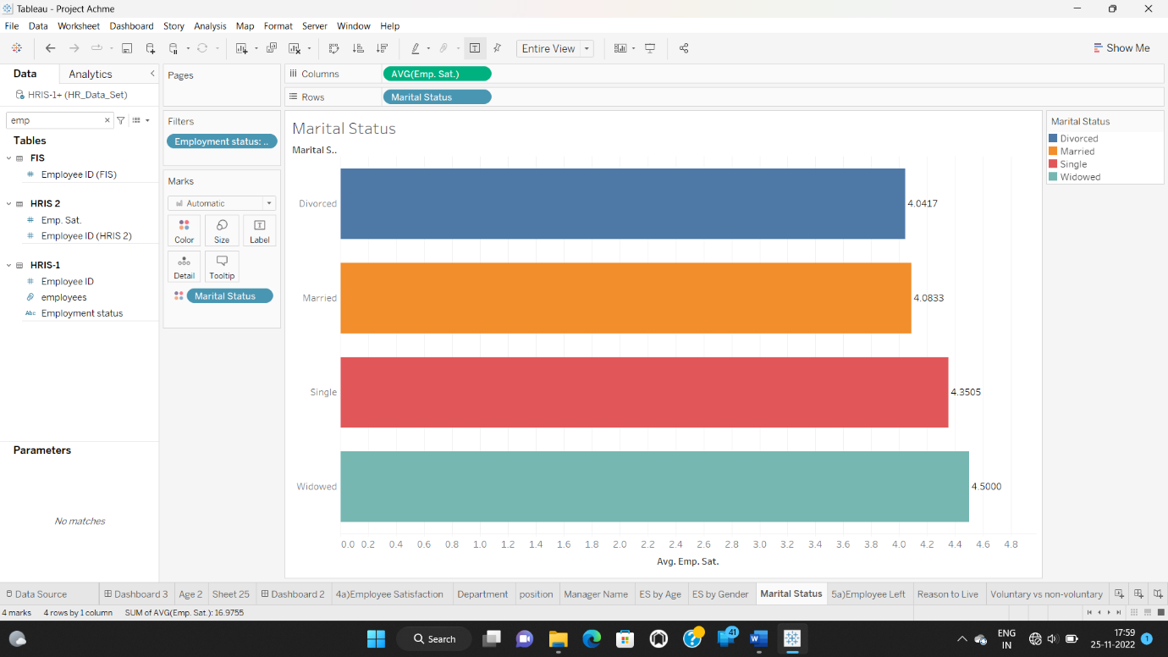

**Insight:** Widowed are more in number as compared to single, married & divorced.